Market Monitor - Somalia - 2026-04

Highlights
Food prices in Somalia rose sharply in April 2026, with significant double-digit increases observed across both local and imported staple commodities. High year-over-year inflation continues to compound food security challenges.
The cost of the food basket increased to SOS 33,287, rising 11.7% (↑) month-over-month. The year-over-year increase of 56.4% (↑) signifies high inflation.
The sharpest monthly price increases were seen in imported rice (20.9% ↑), imported vegetable oil (16.6% ↑), and local white maize (11.7% ↑).
Key drivers of the current market trends include:
- High year-over-year (YoY) inflation in staple foods, with white maize prices increasing 56.4%.
- Significant month-over-month (MoM) price increases across all monitored commodities, led by a 20.9% surge in the price of imported rice.
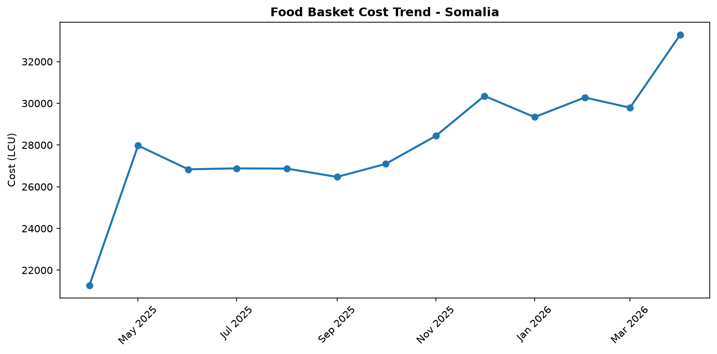
Food basket cost trend

Market Overview
Somalia’s markets are under severe stress, with April 2026 marked by sharp and widespread price increases for essential food commodities. The primary driver is an ongoing and severe drought, which has crippled local agricultural production and exacerbated a nationwide humanitarian crisis. Reports from the month confirm that food insecurity has reached critical levels, with millions facing emergency conditions (IPC Phase 4) and some newly displaced families experiencing catastrophe-level hunger (IPC Phase 5). This supply shock is reflected in significant double-digit month-over-month price hikes for both local and imported staples. The year-over-year inflation for key foods is exceptionally high, further eroding the purchasing power of vulnerable households.
The situation is compounded by a reported collapse in international aid funding in 2025, which has weakened the country's resilience. While some food aid was delivered in April and new funding was announced by the EU and SDC, the market impact of these interventions is not yet evident. Given the severity of the drought and the strong inflationary momentum, food prices are expected to continue their upward trajectory in the near term, deepening the food security crisis.

Commodity Analysis
The cost of a basic food basket surged in April, rising by 11.7% month-over-month and a staggering 56.4% year-over-year, a rate that signifies high inflation. It is critical to note, however, that this calculation is based solely on the price of white maize due to missing data for other basket components. Consequently, the basket's trend directly mirrors the pressure on this key local staple.
The price of white maize, reflecting the food basket's movement, climbed 11.7% from March and is 56.4% higher than in April 2025. This sharp increase underscores the devastating impact of the drought on local harvests and food availability.
Inflationary pressures were even more acute for imported staples. Imported rice saw the most dramatic short-term price shock, surging 20.9% month-over-month. Its year-over-year increase of 44.4% highlights sustained pressure on import supply chains. Similarly, the price of imported vegetable oil rose significantly, increasing by 16.6% from the previous month and 30.4% over the last year. The concurrent, rapid price increases across both locally produced and imported commodities demonstrate the broad-based nature of the current food crisis, severely impacting household access to a diverse and affordable diet.
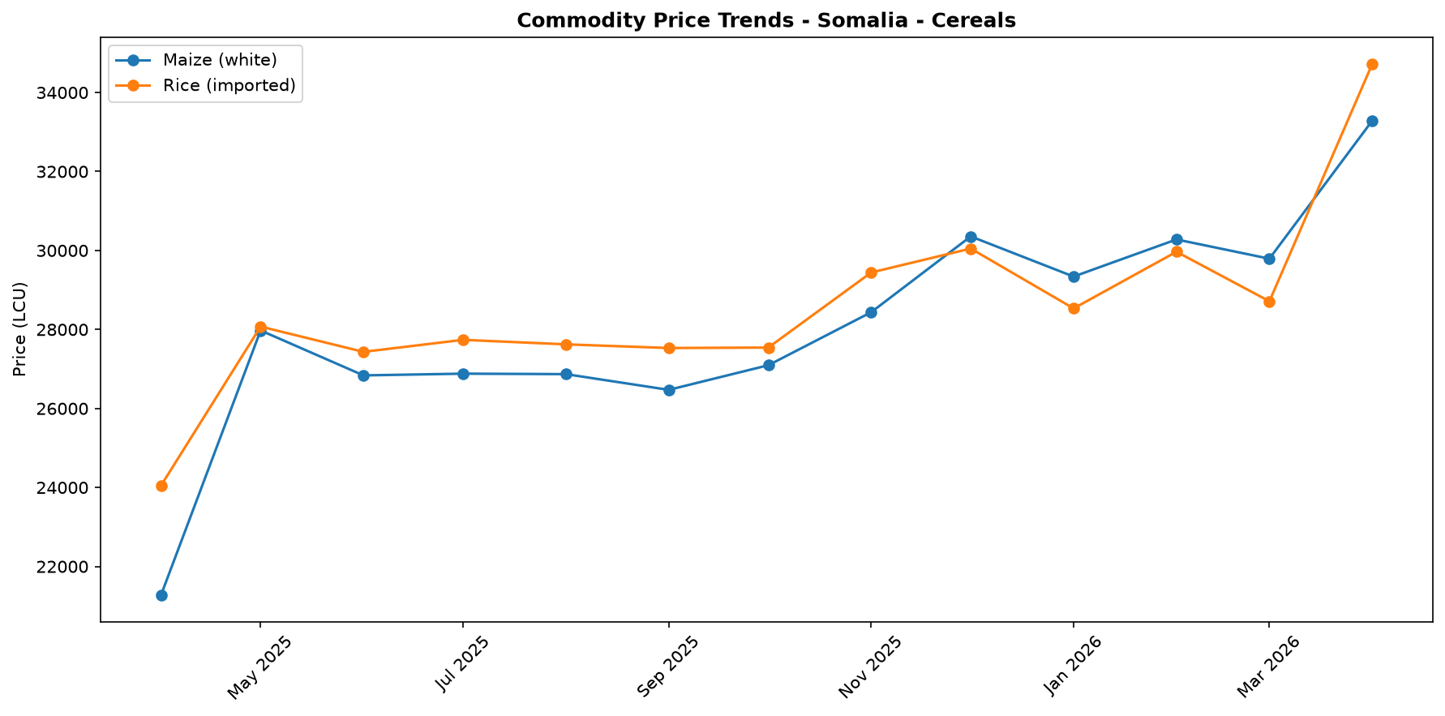
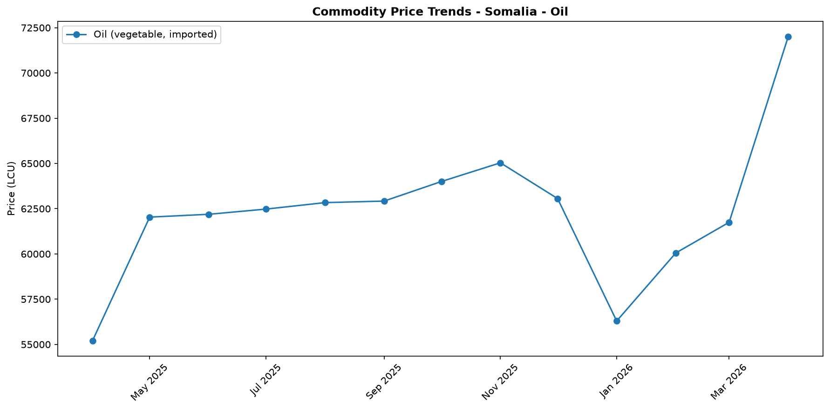

Regional Highlights
While national-level data indicates a widespread crisis, humanitarian reports in April provide insight into regional dynamics and responses. The ongoing drought has driven food insecurity to critical levels across Somalia, with reports highlighting that newly displaced families, in particular, are facing catastrophic hunger (IPC Phase 5). This points to extreme vulnerability in areas absorbing populations fleeing drought-stricken rural regions.
In response, targeted aid operations are underway. For instance, Qatar Charity delivered food parcels to over 2,800 families in northeastern Somalia, providing direct relief in a heavily impacted area. In the Gedo region, a longer-term project was launched in Dollow town by UNHCR and the AfDB to build resilience for displaced persons and host communities. These localized interventions are vital but occur against a backdrop of universally high market prices. The scale of the national crisis suggests that such efforts, while crucial for beneficiaries, may have a limited immediate impact on stabilizing overall market prices across the country.
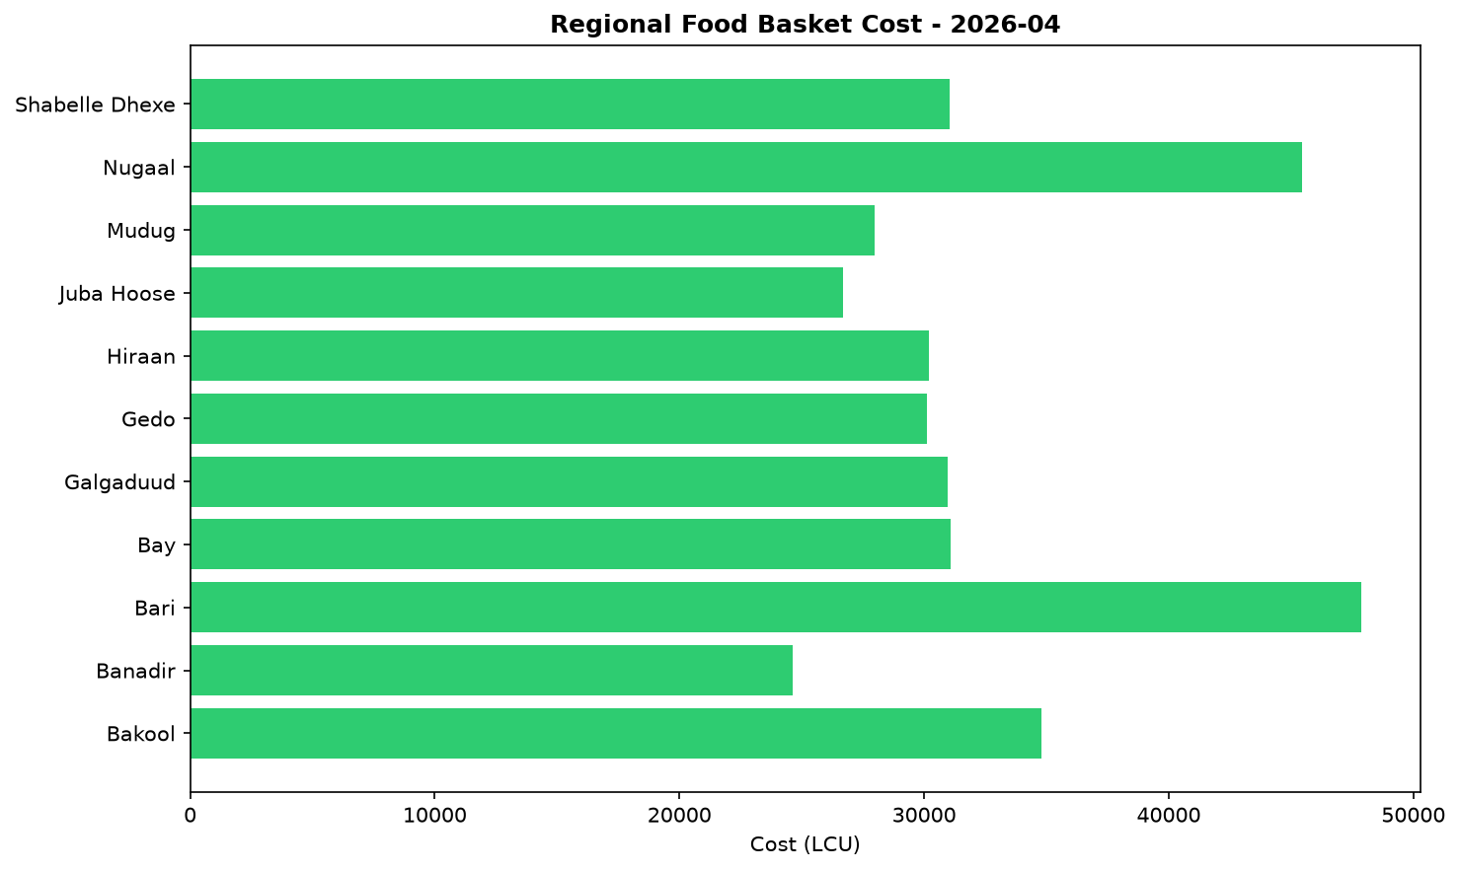

References
- [rw_4210060] ReliefWeb (2026-04-30) Multi-million Euro funding to support drought-stricken communities in Somalia
https://reliefweb.int/node/4210060
- [rw_4209183] ReliefWeb (2026-04-28) Somalia: When aid disappears, childhoods disappear too
https://reliefweb.int/node/4209183
- [rw_4209431] ReliefWeb (2026-04-27) Qatar Charity delivers relief to families hit by severe drought in Somalia
https://reliefweb.int/node/4209431
- [rw_4209449] ReliefWeb (2026-04-27) NRC Somalia Country Office Programme Update No. 23 (31st March 2026)
https://reliefweb.int/node/4209449
- [rw_4209289] ReliefWeb (2026-04-26) New African Development Bank funding to support durable solutions for thousands of internally displaced and host communities in Somalia’s Gedo region in Dollow, Somalia
https://reliefweb.int/node/4209289
- [rw_4209451] ReliefWeb (2026-04-25) Radio Ergo Weekly Feedback Report, Issued: 24 Apr 2026
https://reliefweb.int/node/4209451
- [rw_4209173] ReliefWeb (2026-04-24) Drought displaces nearly 62,000 in Somalia as climate shocks intensify
https://reliefweb.int/node/4209173
- [rw_4209052] ReliefWeb (2026-04-23) Malnutrition and death plague camp in Somalia as drought worsens
https://reliefweb.int/node/4209052
- [rw_4208918] ReliefWeb (2026-04-22) UNICEF Executive Director Catherine Russell’s remarks at the Humanitarian Dialogue – Humanitarian Priorities for Children in 2026
https://reliefweb.int/node/4208918
- [rw_4208856] ReliefWeb (2026-04-22) WFP Somalia Country Brief Apri 2026
https://reliefweb.int/node/4208856
- [seerist_1028391] Seerist (2026-04-30) Global maritime outlook: May 2026
- [seerist_1028308] Seerist (2026-04-24) Local resistance, external pressure likely to undermine federal push to remove Jubaland administration
- [seerist_1028144] Seerist (2026-04-14) Big Picture series: Strait of Hormuz disruption to drive acute fiscal, supply chain challenges in Africa
- [seerist_1027947] Seerist (2026-03-30) Global maritime outlook: April 2026
- [seerist_1027800] Seerist (2026-03-18) Israel likely to quickly expand presence in Somaliland to better counter Houthi threat
- [seerist_1027663] Seerist (2026-03-06) Big Picture series: How the Middle East conflict is likely to impact Sub-Saharan Africa
- [seerist_1027640] Seerist (2026-03-06) Adoption of new constitution to escalate electoral crisis with opposition
- [seerist_1027564] Seerist (2026-03-02) Planned reopening of Kenya-Somalia border to face delays

